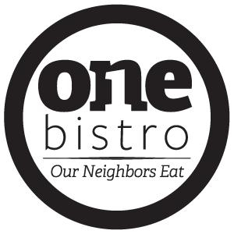

Volunteer Training Manual

March 2021

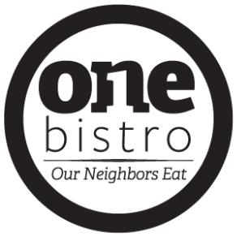

Dear Valued Volunteer,

Welcome to One Bistro! We are excited to serve with you.

One Bistro is nothing without volunteers who give of their time and talent—the heart behind our mission. Given the many opportunities to serve in our community, we appreciate and thank you for choosing to be a part of One Bistro and for your willingness to serve with us.

Our goal is to provide a safe, friendly, enjoyable, and uplifting environment for you to serve. In serving at One Bistro, not only will you be a blessing to the lives you touch, but your own life will also be equally blessed by the good you are doing to make a difference in this community.

Thank you for your interest in serving. We love our volunteers and consider you as part of our One Bistro family.

Sincerely,

Board of Directors and Staff

 | General Information
Managers
Executive Chef: | Greg Shaffer
Front House Coordinator: | Shayne Shaffer
Hours of Operation
Wednesday through Friday: | 11 a.m. to 2 p.m.
Wednesday Evening: | 5 p.m. to 7 p.m.
Saturday: | 8 a.m. to 2 p.m.
Sunday, Monday and Tuesday: | Closed

Our Mission

To provide a place where our neighbors eat and come together as one community.

Our Vision

- Share love, give hope, and provide a sense of community to our neighbors.

- Reach out and help to meet the needs of neighbors, both physically and spiritually.

- Serve privileged and under-privileged neighbors, by giving a hand up, not a hand out.

- Provide healthy, affordable meals in a warm and welcoming environment.

- Eliminate hunger, build relationships, and celebrate community with our neighbors.

Our Values

All neighbors are welcome to sit at our table.

A seat is waiting if you are hungry, or if you have a hunger to help our neighbors and make a difference in this community. We hope a good meal in a warm and welcoming environment will help to feed one’s soul.

Good is in the hands that serve.

We cannot function without volunteers who give of their time and talent—the heart behind our mission. While we pray for volunteers to help bring good into the community by being the hands and feet of Jesus, all are welcome regardless of faith.

Togetherness will satisfy your appetite.

Our neighbors come together. Neighbors from across the street or across town. Those in need of help and those with help to give. All come together to enjoy a good meal and the pleasure of good company.

All may eat with love on the menu.

A meal is affordable for all at $6-$9. Pay what you can afford. Pay the full amount of the suggested price, or a little more to “pay it forward” and help to feed your neighbor. If unable to pay, give time in service as payment.

Community is the chef’s special of the day.

Say hello. Introduce yourself to those around you. Take time to get to know your neighbors and take part in the One Bistro commitment to eliminate hunger, grow relationships, and celebrate community.

Top it off with a “to go” of happiness.

With a core ingredient of love, and a dash of friendship, our hope is that you’ll end the meal with a “to go” of happiness that follows you all the way home.

Our Concept

We embrace a “pay what you can afford” concept by offering a few payment options.

- Pay what you can afford. If unable to pay, give your time in service as payment.

- Pay the full amount of the suggested price.

- Pay the full amount of the suggested price of one meal, plus purchase one (or more) additional meals to “pay it forward.”

Our Menu

– Take a few minutes to review the menu and become familiar with the items offered.

– Current menu selections are available at onebistro.org.

Frequently Asked Questions

What is One Bistro?

A faith-based non-profit Biznistry® established for the betterment of our community. At our core is a place from which we strive to serve a healthy, affordable meal to our neighbors, both those who have the ability to pay and those who under normal circumstances would not be able to eat out. As a Social Entrepreneurship, we exist to help the hungry find a meal. To help the lost find hope. To help the addicted find support. To help the homeless find a sense of home as our One Bistro family. To help the mentally and physically impaired find meaning and acceptance as a valued volunteer. An investment in One Bistro is an investment in people.

What if a customer cannot pay for a meal?

We recognize that times are tough and as such, have embraced a “pay what you can afford” concept. If unable to pay for a meal, guests can give time in service as payment. If able to pay, a suggested price of $6-$9 will cover the cost. All donations over the suggested price will “pay it forward” to cover cost of a neighbor’s meal.

Are reservations accepted?

Although not needed, we do accept reservations. All guests are seated on a first come, first serve basis.

Volunteer Positions

To volunteer, sign up at onebistro.org for any of the following possible volunteer positions. While we do our very best to keep volunteers in requested positions, there may be instances when we ask volunteers to help in other areas as the need arises.

Busser | Dishwasher

Bus Tables. Take Dishes to Sink. Wash and Dry Dishes. Restock.

Front of House | Cleaning

Wrap Silverware. Clean and Stock Beverage Station. Sweep and Mop Floors. Clean Bathroom. Trash Removal.

Wash Windows.

Hostess

Seat Guests. Provide Menu. Explain “Pay What You Can” and “Pat It Forward” Concepts.

Server

Take and Serve Orders. Take Guest Checks to Kitchen. Check for Beverage Refills.

Customer Service

- Welcome your guests like family. Remember we are here to serve the community.

  - Extend a genuine welcome. Introduce yourself: “Hello and welcome to One Bistro. My name is…”

  - Ask guest if this is their first visit to One Bistro. If so, explain the mission and our “pay what you can afford” and “pay it forward” concepts.

O Mission: “To provide a place where our neighbors eat and come together as one community.” O In our “pay what you can afford” concept, we offer a few payment options.

    - Pay what you can afford. If unable to pay, give your time in service as payment.

    - Pay the full amount of the suggested price.

    - Pay the full amount of the suggested price of one meal, plus purchase one (or more) additional meals to “pay it forward.”

  - Make eye contact and smile—a universal way of telling someone you enjoy what you do.
  - Use positive body language—Don’t lean, stand attentively and energetically, always facing your guest.

  - Show kindness and consideration.
    - Good manners are based on respect. Treat patrons and volunteers as guests in your home.
    - Use “please” and “thank you” as often as possible.
    - Anticipate when something isn’t right or if a guest is in need.

- Communicate daily specials and go over menu.

  - Share the daily specials and any changes to the current menu.

  - Take beverage order.

-

- Return with the beverage order.

  - Ask guests if they have any questions about the menu.

- Take the food order.

  - Always repeat order to ensure accuracy. See sample guest checks for instructions on filling out.

Guest Check Sample – Weekday Lunch Guest Check Sample – Saturday Brunch
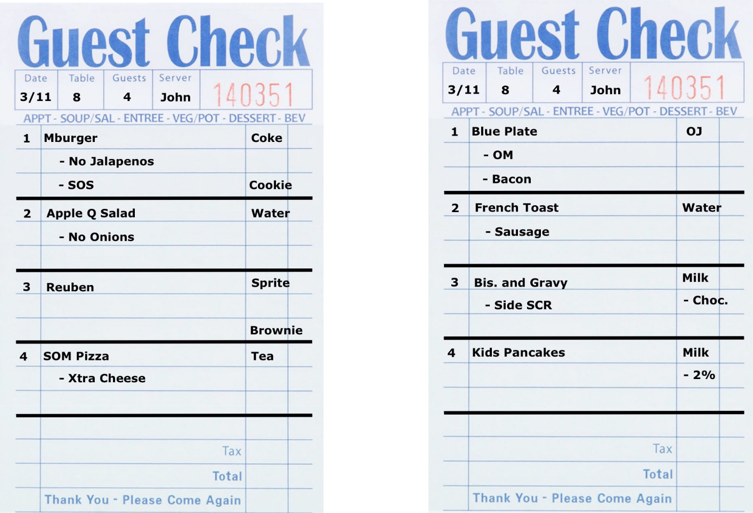

Customer Service

- Place order with kitchen.
  - Ensure the chef has all of the information needed to fill the order.

  - Return to the table and check beverages for refills.

- Serve the meals.

  - Chef calls out “ORDER UP” when the order is ready. Servers are to check food against the ticket and only take food to the table once it is verified.

- Check back within two minutes.
  - Check to make sure the guests are enjoying the meal and it was prepared as requested.

  - Correct any order errors and notify chef.

- Suggest coffee and offer a dessert, if available.

  - Suggest one of your favorites, if available.

  - Offer coffee or hot tea to accompany any dessert order.

- Offer a box to guests for any food they wish to take home.

  - Servers do not box guest food. Guests should be brought an appropriate box to ensure no cross contamination.

- Serve desserts and coffees (if available and ordered by customer).

  - At this point, there should be no empty plates, salads, garbage, dirty silverware, etc. on the table.
  - Bring extra forks for sharing, if guest has ordered a dessert.

- Promptly present the check and provide payment instructions.

  - Sincerely thank guests for dining at One Bistro. Verbalize appreciation and invite guests back. Encourage guests to bring a friend on their next visit.
  - Direct guests to the cash register to make payments.

  - Do not set any guest check with or without cash on the counter.

  - Do not “comp” any meals on your own. Explain the One Bistro concept, but direct guest to take their check to the cash register and speak with the Manager.

  - Please do not assume that someone is asking for a “comp” meal.

Health Code Requirements and Food Safety Guidelines

It is everyone’s responsibility to practice and enforce proper food safety and personal hygiene to prevent contamination. Below are some important health code requirements and food safety guidelines.

Actions That May Contaminate Food:

- Scratching scalp or running fingers through hair.

- Coughing, sneezing or spitting into hand or around food-contact surfaces.

- Wiping or touching the nose, face or ears.

- Touching cell phone or other electronic devices, or anything that may contaminate the hands.

- Touching clothing or apron.

- Touching infected wounds.

- Wearing dirty clothing.

Proper Sanitation and Personal Hygiene:

- Wear gloves when serving or handling Ready-to-Eat foods (a food that is to be given to the customer to be eaten or a food that will not need to be cooked any longer).

- Wear gloves whenever handling raw meat.

- Wash hands frequently and before putting on new gloves.

- Remove aprons when taking out trash or using the restroom.

- Handle glassware and dishes properly. Never touch the food-contact area of the glassware or dishes.

- Hold flatware and utensils by the handles and not by the food-contact surfaces.

- Cloths used for cleaning spills should not be used for anything else.

- Wear clean and appropriate clothing to adhere to the dress code, including, but not limited to, closed toed shoes, tops that cover the shoulders, and hair tied back away from the face and eyes.

- Maintain personal cleanliness, such as showering daily and keeping hair clean.

- Wear a bandage over wounds and a glove over the bandage.

- Remove rings (except plain band), bracelets, watches, or other hand/wrist accessories.

- Use proper hair restraints: long hair in a ponytail or bun, wear hat, hairnet, or scarf/bandana.

- Avoid unsanitary actions (chewing tobacco or gum, smoking or spitting around food or food-contact surfaces.

- Keep short fingernail length (no false fingernails, no nail polish).

When to Change Gloves:

- As soon as gloves become soiled or torn.

- Before beginning a different task.

- At least every 4 hours during continual use.

- After handling raw meat, poultry or seafood.

- Before handling Ready-to-Eat foods.

When to Wash Hands: After…

  - Using the restroom.

- Handling raw meat (before and after).

- Taking out the garbage, cleaning tables or bussing dirty tables.

- Touching the hair, face or body.

- Sneezing, coughing or using a tissue, eating, drinking, smoking, or chewing gum.

- Handling disinfectant, cleaning products, or chemicals.

Safety | Security

- Leave personal belongings in the car to prevent the occurrence of theft.

  - Fire extinguisher is located in the kitchen (by the hand sink) if needed for fire safety.

- Wipe up spills immediately.

- Wear closed toe shoes to protect feet.

- Report accidents and defective equipment or tools to Manager.

- Wear gloves when handling Ready-to-Eat foods to avoid contamination.

- Use caution when picking up hot items or lifting heavy items, and alert others if carrying anything hot.

- Use caution when handling knives or other equipment.

- If you ever feel uncomfortable with an assigned task, please notify Manager.

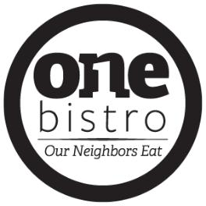

Code of Ethics

Adopted by the Board of Directors

At One Bistro, we are committed to the highest ethical standards. Based on the unique trust placed in One Bistro to serve the public good, we have a special obligation to act ethically.

The success of One Bistro and our reputation depends upon the ethical conduct of everyone affiliated with One Bistro. The Board of Directors, Staff, and Volunteers set an example for each other by pursuit of excellence in high standards of performance, professionalism, and ethical conduct.

While no document can anticipate all of the challenges that may arise, the Code of Ethics communicates key guidelines and will assist the One Bistro Board of Directors, Staff, and Volunteers in making good decisions that are ethical and in accordance with applicable legal requirements. All are encouraged to discuss any questions or concerns they have.

PERSONAL AND PROFESSIONAL INTEGRITY

A personal commitment to integrity in all circumstances benefits each individual as well as the organization. We, therefore:

– Strive to meet the highest standards of performance, quality, service, and achievement in working towards the One Bistro mission.

– Communicate honestly and openly and avoid misrepresentation.
– Promote a working environment where honesty, open communication, and opinions are valued.
– Exhibit respect and fairness toward all those with whom we come into contact.

ACCOUNTABILITY

At One Bistro, we are responsible to our supporters, customers, and others who have placed faith in this ministry.

To uphold this trust, we are committed to:

– Promote good stewardship of One Bistro resources, including contributions that are used to pay operating expenses and salaries.

– Refrain from using organizational resources for personal gain or purposes.
– Observe and comply with all laws and regulations affecting One Bistro.

SOLICITATIONS AND VOLUNTARY GIVING

The most responsive contributors are those who have the opportunity to become informed and involved. We, therefore:
– Promote voluntary giving in dealing with supporters and vendors.
– Refrain from any use of coercion in fundraising activities.

Code of Ethics

DIVERSITY AND EQUAL OPPORTUNITY

As an equal opportunity employer, One Bistro is committed to the principle of diversity. We, therefore:

– Value and embrace diversity in all aspects of One Bistro activities and respect others without regard to race, color, religion, creed, age, sex, national origin, marital status, sexual orientation, or status as of a qualified disabled or handicapped individual.

– Support affirmative action and equal employment opportunity programs throughout One Bistro.
– Refuse to engage in or tolerate in any other form of discrimination or harassment.

CONFLICTS OF INTEREST

To avoid any conflict of interest or the appearance of a conflict of interest, which could tarnish the reputation of

One Bistro as well as undermine the public’s trust in One Bistro, the Board of Directors, Staff, and Volunteers will:

– Avoid any activity or outside interest which conflicts or appears to conflict with the best interest of One Bistro, including involvement with a current or potential One Bistro vendor, grantee, or competing organization, unless disclosed to the Director and not deemed to be inappropriate.

– Ensure that outside employment and other activities do not adversely affect the performance of their One Bistro duties and or achievement of One Bistro’s mission.

– Ensure that travel, entertainment, and related expenses are incurred on a basis consistent with the mission of One Bistro and not for personal gain or interest.

– Decline any gift, gratuity, or favor in the performance of One Bistro duties except for promotional items of nominal value, and any food, transportation, lodging, or entertainment, unless directly related to One Bistro business and with prior disclosure to the Director.

– Refrain from influencing the selection of consultants or vendors who are relatives or personal friends or affiliated with, employ, or employed by a person with whom they have a relationship that adversely affects the appearance of impartiality.

VOLUNTEERS

The volunteers at One Bistro should not:

– Knowingly take any action or make any statement intended to influence the conduct of One Bistro in such a way to confer any financial benefit on themselves, their immediate family members, or any organization in which they or their immediate family members have a significant interest as stakeholders, directors, or officers.

– Disclose all known conflicts or potential conflicts of interest in any matter before the Board of Directors, if they are Board Members, or any committee upon which they serve and withdraw from the meeting room during any discussion, review, and voting in connection with such matter.

Members of the Board of Directors shall annually file with the One Bistro Staff a disclosure of all known potential conflicts of interest.

Code of Ethics

CONFIDENTIALITY AND PRIVACY

Confidentiality is a hallmark of professionalism. We, therefore:
– Ensure that all information, which is confidential, privileged, or nonpublic, is not disclosed inappropriately.
– Respect the privacy rights of all individuals in the performance of their One Bistro duties.

POLITICAL CONTRIBUTIONS

We encourage individual participation in civic affairs. However, as a charitable organization, One Bistro may not make contributions to any candidate for public office or political committee and may not intervene in any political campaign on behalf of or in opposition to any candidate for public office. We, therefore:

– Refrain from making any contributions to any candidates for public office or political committee that may create appearance that a contribution is from One Bistro.

– Refrain from using any organizational financial resources, facilities, or personnel to endorse or oppose a candidate for public office.

– Clearly communicate that we are not acting on behalf of the organization, if identified as an official of One Bistro, while engaging in political activities in an individual capacity.

– Refrain from engaging in political activities in a manner that may create the appearance that such activity is by or on behalf of One Bistro.

DOCUMENT DESTRUCTION

The Law makes it a crime to alter, cover up, falsify, or destroy any document or persuade someone else to do so, or to prevent its use in an official proceeding (i.e. federal investigations or bankruptcy proceedings). Intentional document destruction will be monitored, justified, and carefully administered.

GUIDANCE AND DISCLOSURE

Reports of possible breaches of the Code of Ethics will be handled in the following manner:

– All reports of possible breaches will be treated in confidence as much as the organization’s duty to investigate and the law allow. If confidentiality cannot be maintained, the individual disclosing the possible breach will be notified.

– All reported breaches will be investigated by the Director and/or the Board of Directors, as appropriate. If needed, appropriate action will be taken based upon the policies of the organization.

– No director, officer, or employee who in good faith reports a violation of the code shall suffer harassment, retaliation, or adverse employment consequence. An employee who retaliates against someone who has reported any violation in good faith is subject to discipline up to and including termination of employment.

– This Whistleblower Policy is intended to encourage and enable employees and others to raise serious concerns within the organization prior to seeking resolution outside the organization.

– We, at One Bistro, affirm prompt and fair resolution of all reported breaches.

Code of Ethics

Glossary

Candidate for Public Office: An individual who offers herself or himself or is proposed by others as a contestant for an elected public office, whether such office is federal, state, or local.

Contribution, Political: Anything of value, including monetary and in-kind gifts, provided for the purpose of influencing the outcome of an elections.

Donors: All individuals and entities that make charitable or in-kind contributions to One Bistro.

Non-Public Information: Any business, financial, or personal information, which is not publicly known or available.

Political Committee: Any party, committee, association, fund or other organization organized and operated primarily for accepting contributions to influence the selection, nomination, or election of any individual to any federal, state, or local office.

Privileged Information: Any information that is protected from involuntary disclosure by legally recognized privileges such as attorney-client, doctor-patient, and others.

Promotional Items of Nominal Value: Gifts used to promote and organization’s name, products, or services that have a retail value of $25 or less.

Representatives: Individuals who provide personal services to one bistro as independent contractors, consultants, or loaned executives.

Staff: All individual who provide services to One Bistro as employees or leased employees.

Vendors: Entities that provide goods and services to One Bistro for a fee.

Volunteers: All persons who voluntarily work at One Bistro, but who are not members of the One Bistro Board of Directors or Staff.

Volunteer Health Policy

The purpose of this policy is to ensure that Employees or Volunteers notify the Manager or Person in Charge when experiencing any of the conditions listed below, so appropriate steps may be taken to preclude the transmission of foodborne illness.

Reporting: Symptoms of Illness

I agree to report to the Manager or Person in Charge before volunteering when I have:

- Diarrhea

- Vomiting

- Jaundice (yellowing of the skin and/or eyes)

- Fever or sore throat with a fever

- Infected cuts, wounds or lesions containing pus on hand, wrist, or exposed body part (such as boils and infected wounds, however small), which may come into contact with food or food contact surfaces.

- Chills/Sweats

- Head/Body Aches or Dizziness

- Persistent sneezing, coughing or a runny nose that causes discharges from eyes, nose or mouth.

Reporting: Diagnosed Illnesses

I agree to report to the Manager or Person in Charge before volunteering when I have:

1. | Campylobacter | 7. | Hepatitis A Virus
2. | Cryptosporidium | 8. | Norovirus
3. | Cyclospora | 9. | Salmonella spp. (non-typhi)
4. | Entamoeba Histolytica | 10. | Salmonella Typhi (typhoid fever)
5. | Giardia | 11. | Vibrio Cholerae
6. | Enterhemorrhagic or | 12. | Yersinia
 | Shiga Toxin-Producing Escherichia Coli | 13. | Shigella (shigellosis)

Any volunteer diagnosed with any of the following illnesses must:

- Report it to the Manager or Person in Charge.

- Be excluded from dishwashing or working around food.

- Contact the Combined Health District – Environmental Health Division in your county.

- Not report back to work as a volunteer until no longer infective and/or a possible carrier.

Exclusions and Restrictions

If you have any of the symptoms or illnesses listed above, you may be *excluded or **restricted from volunteering at One Bistro.

*If you are excluded, you are not permitted to volunteer.

** If you are restricted, you are permitted to volunteer, but your duties may be limited.

Please sign and date the Volunteer Agreement and submit to the Manager. A copy is available upon request.

Volunteer Meal Exchange Policy

One Bistro is a faith-based non-profit Biznistry® established for the betterment of our community. At our core is a place from which we strive to serve a healthy, affordable meal to our neighbors, both those who have the ability to pay and those who under normal circumstances would not be able to eat out. As a Social Entrepreneurship, we exist to help the hungry find a meal. To help the lost find hope. To help the addicted find support. To help the homeless find a sense of home as our One Bistro family. To help the mentally and physically impaired find meaning and acceptance as a valued volunteer. An investment in One Bistro is an investment in people.

In order to sustain the mission of One Bistro, and because the restaurant operates almost exclusively on volunteer labor, it is important that guidelines are established when volunteers are eligible for a meal.

Volunteers include those who work:

- As a means of payment for their meal.

- As a court/judiciary appointed community service.

- As an act of simply giving of their time.

Those who are unable to pay for a meal are asked to volunteer a minimum of one hour as a means of payment and will be compensated with a $6 meal from our menu.

Thank you for your time and your interest in serving at One Bistro!

Elevator Speech

(Basically, who we are…and what we do!)

One Bistro is a faith-based, non-profit Biznistry® established for the betterment of our community. At our core is a place from which we strive to serve a healthy, affordable meal to our neighbors, both those who have the ability to pay and those who under normal circumstances would not be able to eat out. As a “pay what you can afford” restaurant, anyone who walks in our doors will enjoy a meal, regardless of their ability to pay. If a patron is unable to pay, we ask them to give an hour or two of their time in exchange for a meal. Other patrons that are able to pay are asked if they would be willing to “pay it forward” to help with the cost of someone else’s meal. It’s a simple concept which allows everyone to be a part of our community. In doing so, this concept gives the opportunity for all of our neighbors to walk out our doors, not only with a full stomach, but also a full heart.

As a Social Entrepreneurship, One Bistro exists to help the hungry find a meal. To help the lost find hope. To help the addicted find support. To help the homeless find a sense of home as our One Bistro family. To help the mentally and physically impaired find meaning and acceptance as a valued volunteer. An investment in One Bistro is an investment in people.

